Rakel María Brynjólfsdóttir rmb3@hi.is
Dæmahópur 9 skil: 30.10.15
Dæmatímakennari: Kristófer Montazeri

Tölvunarfræði 1
Heimadæmi 9

Dæmi 1

Leyndo(4,5) skilar 1024, og almennt skilar það a^b.

Dæmi 2

public class RecursivePower {

public static int exp(int base, int n) {
if(n == 0) return 1;

else return base * exp(base, n-1);
}

public static void main (String[] args) {
int base = Integer.parseInt(args[0]);
int n = Integer.parseInt(args[1]);
System.out.println(exp(base, n));
}
}

Dæmi 3

fn=f(n-1) + f(n-2) - f(n-5)

Með endurkvæmni:

public class Fibonacci4 {
public static long fib(int n) {
if (n == 0) return 0;
if (n == 1) return 1;
if (n == 2) return 1;
if (n == 3) return 2;
if (n == 4) return 3;
if (n == 5) return 4;
else return fib(n-1) + fib(n-2) - fib(n-5);
}

Með fylki:

public class Fibonacci4 {

public static long fibo(int n) {
long[] f = new long[n+5];

f[1] = 1;
f[2] = 1;
f[3] = 2;
f[4] = 3;
f[5] = 4;

for (int i=6; i<=n; i++) {
f[i] = f[i-1] + f[i-2] -f[i-5];
}
return f[n];
}

public static void main(String[] args) {
int N = Integer.parseInt(args[0]);
StdOut.println(fibo(N));
}
}

Dæmi 4

Nr 1:

public static void draw(int n, double x, double y, double size) {
if (n == 0) return;

// 2.2 ratio looks good
double ratio = 2.2;

// recursively draw 4 smaller trees of order n-1

draw(n-1, x - size/2, y - size/2, size/ratio); // lower left
draw(n-1, x - size/2, y + size/2, size/ratio); // upper left
draw(n-1, x + size/2, y + size/2, size/ratio); // upper right
drawSquare(x, y, size);
draw(n-1, x + size/2, y - size/2, size/ratio); // lower right
}

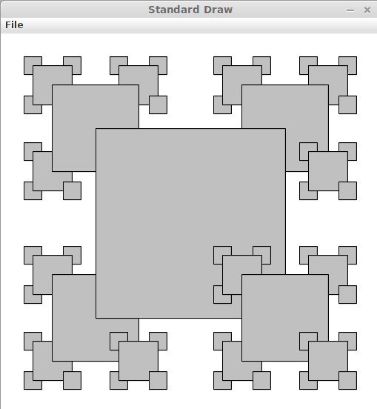

Nr 2:

public static void draw(int n, double x, double y, double size) {
if (n == 0) return;

// 2.2 ratio looks good
double ratio = 2.2;

// recursively draw 4 smaller trees of order n-1
drawSquare(x, y, size);
draw(n-1, x - size/2, y - size/2, size/ratio); // lower left
draw(n-1, x - size/2, y + size/2, size/ratio); // upper left
draw(n-1, x + size/2, y + size/2, size/ratio); // upper right
draw(n-1, x + size/2, y - size/2, size/ratio); // lower right

}
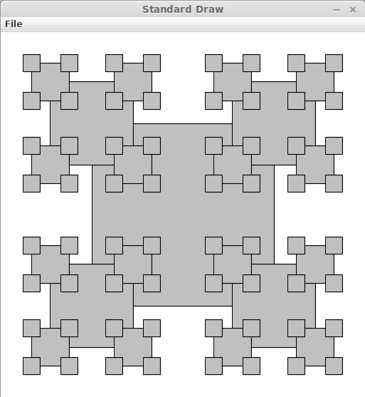

Nr 3:

public static void draw(int n, double x, double y, double size) {
if (n == 0) return;

// 2.2 ratio looks good
double ratio = 2.2;

// recursively draw 4 smaller trees of order n-1
drawSquare(x, y, size);

draw(n-1, x - size/2, y + size/2, size/ratio); // upper left
draw(n-1, x + size/2, y + size/2, size/ratio); // upper right
drawSquare(x, y, size);
draw(n-1, x + size/2, y - size/2, size/ratio); // lower right
draw(n-1, x - size/2, y - size/2, size/ratio); // lower left

}

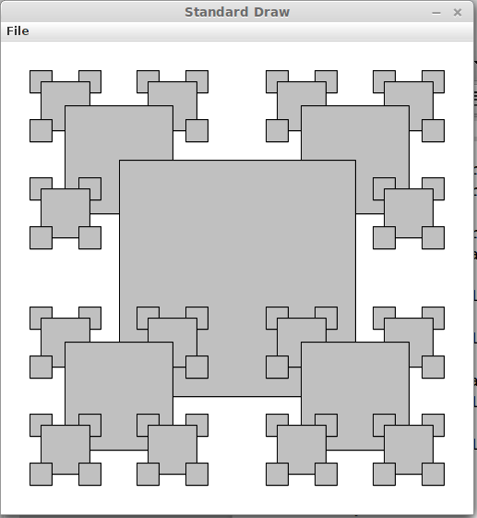

Dæmi 5

public class MySierpinski {

public static void drawTri(double[] x, double[] y) {
StdDraw.filledPolygon(x,y); }

public static void draw(int n,double x0, double x1, double x2, double y0, double y1, double y2 ) {
if (n==0) return;

double [] x = new double[3];
double [] y = new double[3];

x[0] = (x0+x1)/2.0;
x[1] = (x1+x2)/2.0;
x[2] = (x2+x0)/2.0;
y[0] = (y0+y1)/2.0;
y[1] = (y1+y2)/2.0;
y[2] = (y2+y0)/2.0;

StdDraw.setPenColor(StdDraw.WHITE);
drawTri(x,y);

draw(n-1, x[0], x[1], x1, y[0], y[1], y1);
draw(n-1, x[1], x[2], x2, y[1], y[2], y2);
draw(n-1, x[2], x[0], x0, y[2], y[0], y0);
}

public static void main (String[] args) {
int N =Integer.parseInt(args[0]);

double[] x = {0.0, 0.5, 1.0};
double[] y = {0.0, 0.866, 0.0};

double x0 = 0.0, y0 = 0.0;
double x1 = 0.5, y1 = 0.866;
double x2 = 1.0, y2 = 0.0;

StdDraw.setPenColor(StdDraw.BLACK);
drawTri(x,y);
draw(N, x0, x1, x2, y0, y1, y2);
}
}

